Example of a Word document from R software
This Word document has been generated from R software using ReporteRs package.

Plots
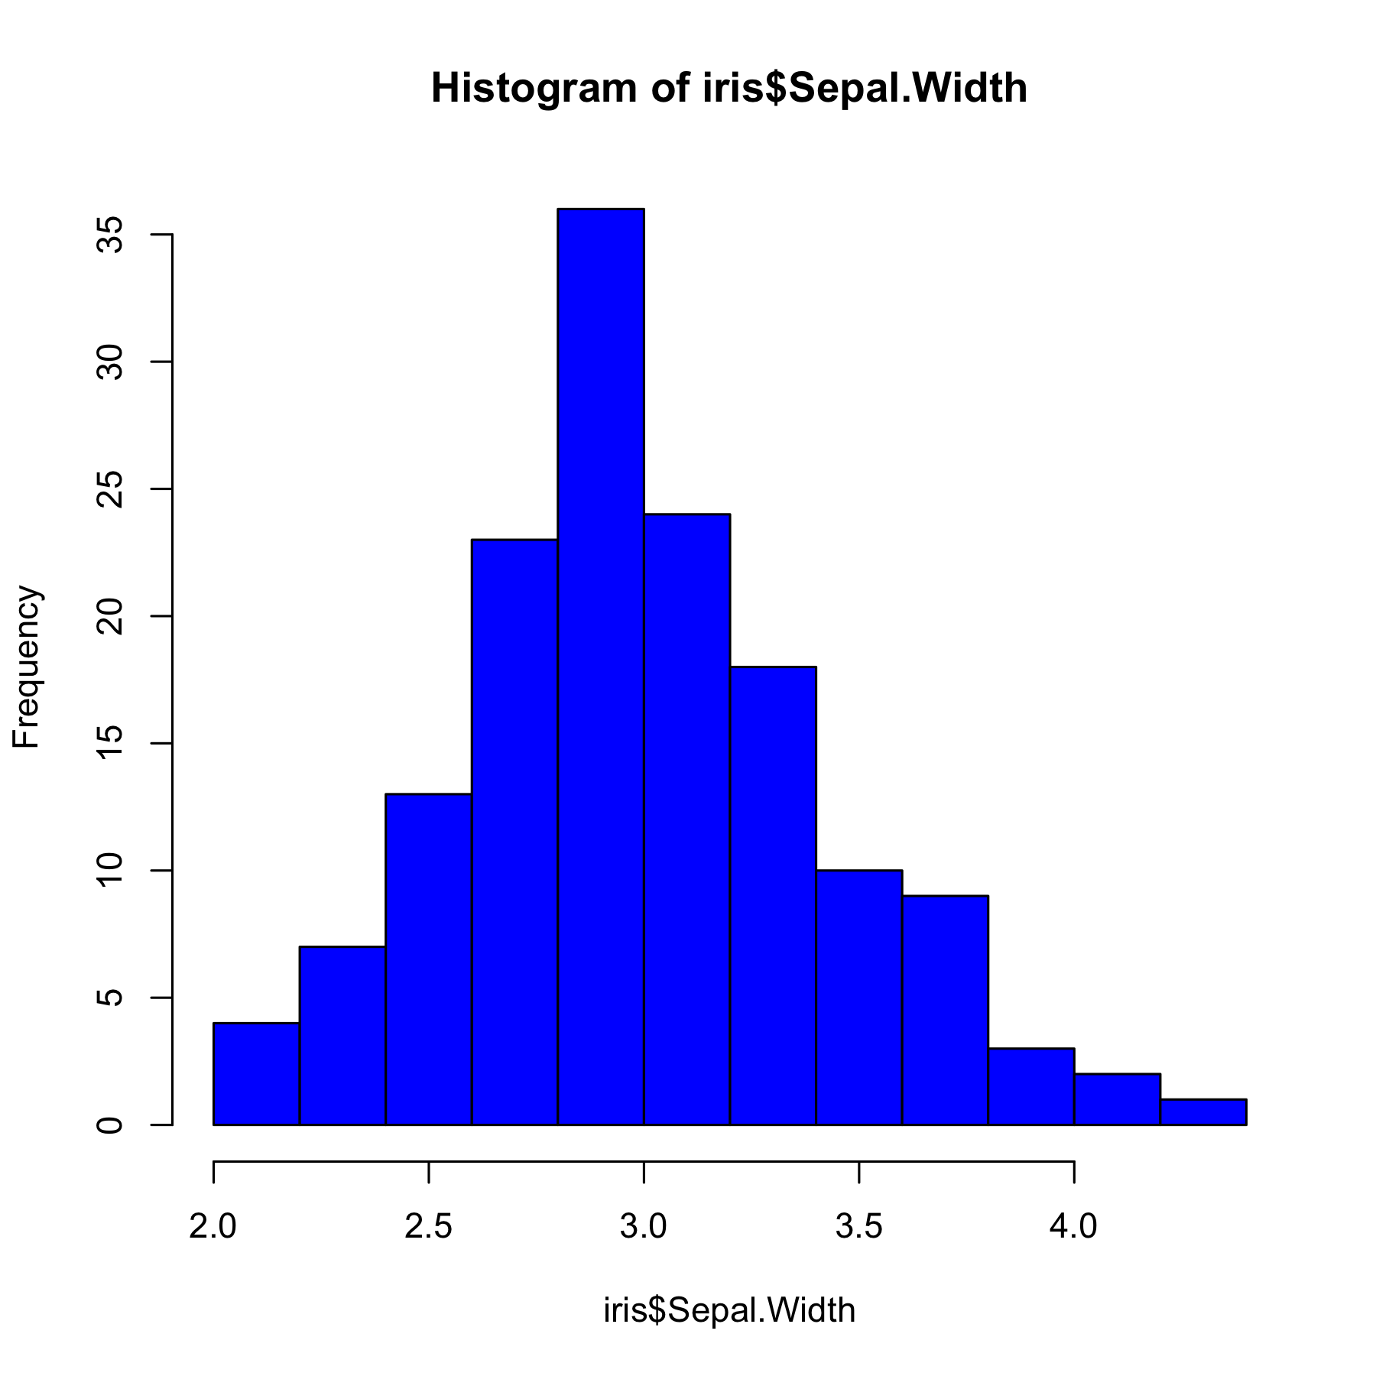

Table
 | Sepal.Length | Sepal.Width | Petal.Length | Petal.Width | Species
1 | 5.100 | 3.500 | 1.400 | 0.200 | setosa
2 | 4.900 | 3.000 | 1.400 | 0.200 | setosa
3 | 4.700 | 3.200 | 1.300 | 0.200 | setosa
4 | 4.600 | 3.100 | 1.500 | 0.200 | setosa
5 | 5.000 | 3.600 | 1.400 | 0.200 | setosa
6 | 5.400 | 3.900 | 1.700 | 0.400 | setosa
7 | 4.600 | 3.400 | 1.400 | 0.300 | setosa
8 | 5.000 | 3.400 | 1.500 | 0.200 | setosa
9 | 4.400 | 2.900 | 1.400 | 0.200 | setosa
10 | 4.900 | 3.100 | 1.500 | 0.100 | setosa

